P3 M3 D3

**Lost Island**

[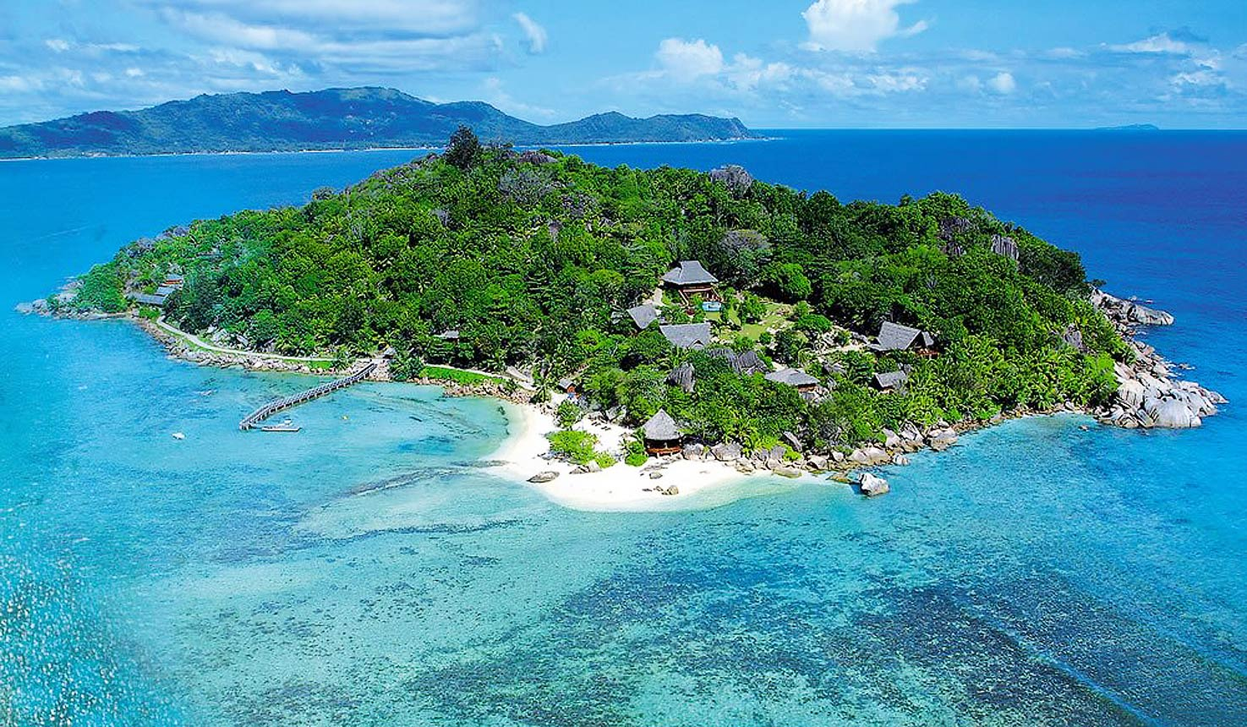](http://www.google.co.uk/url?sa=i&rct=j&q=&esrc=s&frm=1&source=images&cd=&cad=rja&uact=8&docid=eeN00ATFf0d3sM&tbnid=QYVwbNV32kQ_2M:&ved=0CAYQjRw&url=http://www.africatravelresource.com/africa/seychelles/inner/praslin/praslineast/round-island-lodge/&ei=00sgU-jnCsOg0QWMvYGIDA&bvm=bv.62788935,d.ZGU&psig=AFQjCNGLX4Zjm9QWFTj8sQROgYp4qCOgGg&ust=1394711886459253)

By Usman Basharat

12/03/2014

**Executive Summary**

* The game starts off with a lost boy that has lost his parents during a trip to New York. He doesn’t know how he got there. This is an animated mini-story, giving a summary of the game.
* It will start with a brief cut-scene where the user has to understand the back story of the player. Therefore, how he got on the island; when he got there. It will show subtitles so the user can read what has happened
* This new game can explore new features and he has to find his way to get out of the island. The ‘old man wanted him to be a hero. This is where David got his inspiration from.
* The only weapons that David has is a boat and a knife. He can use the boat, but he will get attacked on the way. He has to survive the vital part of the game.
* The player has to choose which character they have to be. Once chosen, they cannot choose again. The three character is:
* Warrior
* Archer
* Magician
* Once he has survived, he gets to choose where to go: USA, UK, France, Germany or Spain.
* The aim of the game is to survive.
* Each player has available to upgrade- strengths, defence, attack. These three are key as there upgrades depend on which character they choose.
* The player has a minimum of 3 lives. Once these three lives are over, the player has to restart the game. However, the player can pick up more lives once they reach the city.
* The player lives like a normal person in the city.
* They will pick up money and they should have enough to purchase a house.
* The player can pick up cash whilst completing quests.
* The quests are important as they would need this to become a better hero.
* The better the player becomes, the harder the quests will become and the rewards would be greater.
* Tutorials will be available for each player if they are new to the game. They can be another section of all the tutorials.
* As for every game, the user has to save the game section they are on. If not, they will have to start where they was previously.

**Game Overview**

**High concept**

The concept of the game is for the user to survive. He can be attacked by random source of enemies and he has to get out of the island as soon as possible. David is on an unknown island. This means that he cannot get help from any person. The only help he can use is the boat. They are mini quests on the island to gain strength. In this game, there is no ending. Once David has found his parents, he can build a ‘mini’ clan. This can make archenemies with his clan. It can continue from that point. David got lost at the age of nine. He is seven-teen once the player continues. He gets old just like every human being.

**Genre**

The genre of this game is action and adventure. It could relate to the theme of spy but the main genre is action and adventure. It is action, because they will be a lot of action and the player using weapons, throughout the game to kill the enemies. It is adventurous because the player has to find his parents anywhere in the named planets. Whilst he tries to find his parents, he comes across new quests. This makes it adventurous.

**Hooks**

The hooks for this game are vital. This is being used to make the graphics and animated images to become modelling reality gameplay. This is important for the graphics to be up-to-standard for the players. Any gamers want high definition gameplay. If you have not that good of graphics, it would not attract any gamer to play your game. For example, in GTA, it demonstrates real-life objects and buildings. This is why people want to buy the game. The graphics is one of the objects that designers have to get right.

Lost Island would contain the player to have two perspectives of the game. The first is first person and third person. A third person and first person perspective allows the user to change the dimensions whilst they are playing the game. They could use first person view (when you see through the eyes of the person) or third person (when you see the body of the player).

**Licence**

Licence in any game is important in any game. The licence is important because they need permission for the use of owners to implement it in the game. If there is no licence on the product, the owner could take the company to court. The game can be published once the owner has granted permission. This results in paying a huge fine. The licences that I will require in my game is the following:

* Music
* Clothes
* Engine noises

The licence for **music** is needed in my game, because once the user is driving a car, music can be turned on and off. The music playing should be licenced. The artists that is played on the track of the car, the artist should grant permission. Another licence that we will need is **engine noises**. It is for the use of engine noises of each vehicle that is being used in the game. Because these sounds will be taken from real car currently in the market (BMW, Mercedes etc.), the development team will need to seek permission from the company before implementing the sound in Lost Island. This licence will be enabled once the licence is accepted. The same is for **clothes.** If any brands e.g. Nike is used in my game, I would need permission of the company.

**Online Highlights**

The online highlights for Lost Island is that they are a few requirements for the user to use online mode. To co-operate with other users, the player has to have internet connection. This would enhance experience and new quests that the player would not know. Playing with others could be better because it could complete quests that one user may be stuck at.

The internet connection must be connected with the console. For example, PS3, it must have internet connection to play an online mode. The connection could be wireless or connected with an Ethernet cable. Wireless is risky. If the internet modem is far from the console, most likely, the internet connection is going to be slow. Ethernet cable is the best for connection. However, the console must be right next to the modem/router for the cable to connect with the console. Having fast internet connection, it would allow the player to use the internet much quicker. If the internet connection is slow, talking and playing with others would be slow to play.

**Technology Highlights**

The technology highlights could become useful with the more accessories you get with the console. For example, PS3 you can use a headset and actually talk verbally with your other opponent. One of the biggest advantage is that the more accessories you have with the console, the easier it is to play the game. It becomes easier to communicate with your opponent. Having a headset, you can only communicate with people when there are only in an online mode.

**Arts and Audio Highlights**

The audio from this game can vary depending on where you are listening to the audio. The player could have a music player where they play music. The genre of the music could be:

* Hip-Hop
* RNB
* Rap

Other than music, the realistic sound effects will be into play e.g. the sound effects of shooting a gun. It makes the gameplay much more effective and realistic. The speakers could be any type as long as there is sound with the TV. The arts could be effective as it can be put onto the walls and background.

**Production Details**

**Hardware**

Some games have some number of requirements that you have to fill before you play the game. If you do not meet any or one of the requirements, you cannot play the game. For example, if you play GTA and the PS3 RAM is only 20GB, you will not be able to save a lot of gameplay that you would want to play. In my game, the minimum requirements that the user will be needing is the following:

* Minimum RAM: 4GB
* Internet connectivity
* Sound
* Screen 20”
* Headset (depending on the console)

The console depends on which requirements you have to meet. The main consoles that I’ll be putting in my game is:

* PS3
* PS4
* XBOX 360
* XBOX ONE

These are the requirements that the above have to fill in order to play the game. If you save the game and your console is out of 40GB, you could save plenty of gameplay on the console. It depends on how much gigabytes you have in order to save it.

**\*NOTE* WITHOUT ANY OF THESE NAMED, THE GAME WILL NOY RUN CORRECTLY**

**Current Status**

The status on the game is that it is in the design process mode. I will be first designing the aspects on paper. Designing the game is important as view of how the game is going to look like. You can change any ideas on the way. The aspects of what I am going to put in my game are:

* Buildings
* Cars
* Characters
* How the island and gameplay would look like

Even if you find anything that you do not like, it would not be part of the ‘actual’ gameplay. You can cut out things that you find not good enough or you can add new ideas that you have. After designing the game, the actual design will be on the computer. It is important that the designers design the characters that I show them on my mini paper design.

**Budget**

The budget is important as it tells us what we are going to buy it to design the game. I believe that having **£450,000** to spend is decent. I have more to spend, but this is the minimum amount I will be using. If I have to spend more, I will spend more. This is because I believe that customers have a real chance to have a real life experience in my game. Having a decent budget, it will allow me to spend and get high-tech computers and a range of equipment. Usually, gamers would have a lower budget then I have set. I believe that the more you spend the better game you will come. It could come handy in the future.

**Schedule**

Currently, the designing of the game will take around 3-4 months. It will take an extensive period because I want the game to be at its best. Once the game has been produced, we will ask customers of how they feel about the game. If they feel that more ideas/features should be added, we will take on the feedback and fill in the features that they want. I will be doing a survey of around 100 people and a feedback form of how they felt. This is because I will know how they feel about the game. If any enhancements would be needed, I will take another month to repair them.

The official release date will be on the 26/04/2014. By this date, errors will be eliminated and it will be ready to release. I will release the game and do a discounted price for only a short time to get more customers. I will promote the game to the whole wide world.

**Competition**

The competition for this game is vital. This is where the customers come into play. If the customers doesn’t like the game, they will go for the competitor’s game. It is important that the design and features of the game match the competitors. The main competitor that I will be facing is Tomb Raider. It is similar and, obviously, we want to be bigger and better than our competitors are. We have to be aware of our competitors. In this amusement, one of the things that the player can do is drive a vehicle around the encompassing environment, which helps them, get to places speedier and execute the foes.

**Development Team**

The development team will consist of different sections for the game. It will consist of the following:

* Research and Development Team
* Updating the game
* Designing the game
* Future game ideas

These are the four departments that I will need. The research and development team will work on the game before it will been released. They will need to pass their work onto the designing team where they physically design the team. The updating team will need to get ideas from the research team and work together to get the updates. Finally, future team will work on the next game that we will be releasing. They all work together as one team to get this game where I want it to be.

**Game world**

**Background Story**

**Initial Harmony**

The story is based on a person being lost. David was a boy, around 9 years old, when departed his parents on a cruise to New York. He got lost on an island where his parents never knew whereabouts he was. During his time, he found a good friend where he told a ‘mini’ story to David. He told him that he has to be a success during his time and gave him three options to be a hero: magician, archer or warrior. He never was forced into being a hero. The old man persuaded him to do it. He told him old stories of his time for being a hero.

**Quest**

One of these cities, he will find his parents. Once this is complete, the user will be rewarded. David is another player, so if the user is in need, he can use David to help him.

**Hero discovered**

The old man had told him that there is a ‘lost world’ in the five countries: USA, UK, Germany, France and Spain. In one of these, you will have fight of the powerful dragons who have been destroying lives. It was up to David…unfortunately, the old man had passed away. Having been told from the old man, it was up to David to sort out ‘lost world’.

Objective

**Characters**

Every role of each character is specific and plays an important role in my game. In every game, they are different characters. For example, you go to the wise man to heal your health after each battle. I think that it is important in my game for every character to have different roles and powers in them. In different games, they are types of characters. Users will be given a choice to choose from:

* Magician
* Archer
* Warrior

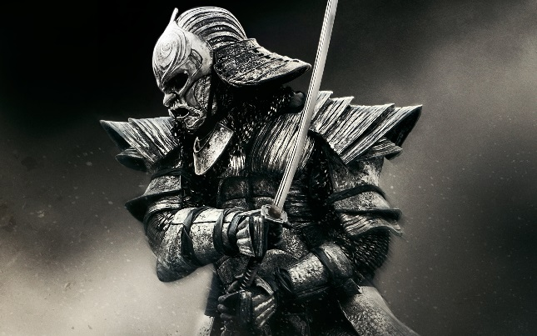 In my game, they will be a warrior where the user has a choice to dress the character. It will only use melee as the attacking option. They won’t be any magic or ranging option. They can use other defences with melee option by using a defender to defend itself when battling an enemy.

[**http://www.hdwallpapers.in/walls/warrior_in_47_ronin-wide.jpg**](http://www.hdwallpapers.in/walls/warrior_in_47_ronin-wide.jpg)*Accessed 05/03/2014*

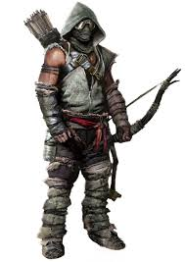

This is a ranger. Again, another option for the user to use. It will have a bow and some arrow. It will use the arrows to kill enemies when threatened. The aim of the game is to survive. The user must choose the best character for them to survive. If the user is about to die, it can use a sword to defend itself. However, the sword after the battle will automatically disappear.

[*http://www.creativeuncut.com/gallery-21/tr-scavenger-archer.html*](http://www.creativeuncut.com/gallery-21/tr-scavenger-archer.html) *Accessed 06/03/2014*

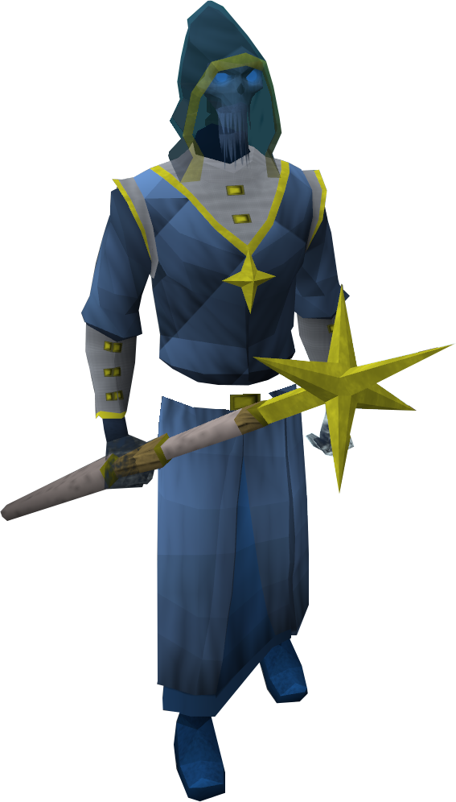The last option throughout the game would be the magician. It uses spells to punish enemies for its survival. All of the characters would look the same. The image is to present how the character would roughly look like. It would looks similar like the ranger.

[**http://img1.wikia.nocookie.net/__cb20130923195804/runescape/images/1/16/Spirit_mage.png**](http://img1.wikia.nocookie.net/__cb20130923195804/runescape/images/1/16/Spirit_mage.png)

*Accessed on 06/03/2014*

# As any other game, they will be other characters to help you out. It will be a much longer list if I name them, but these ones are the main characters that would be involved.

**Enemies**

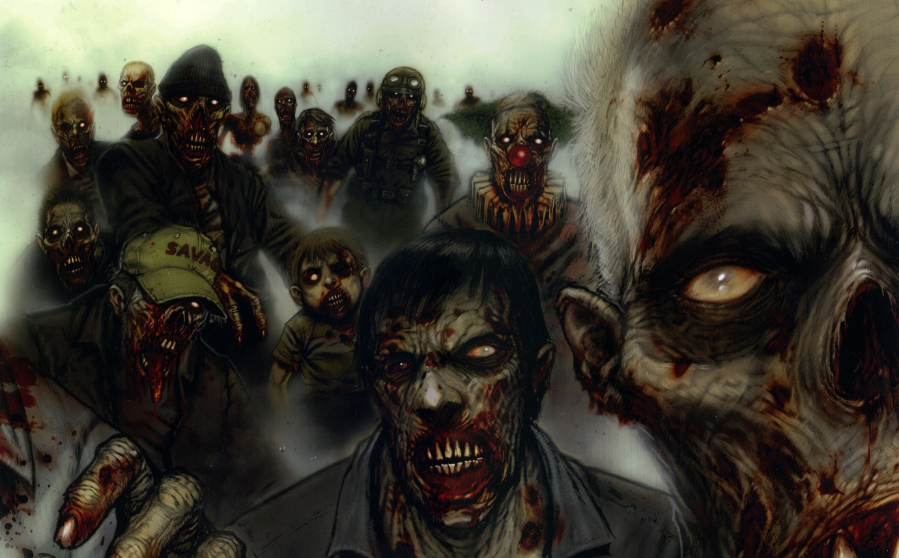The enemies differ from other the worlds selected by the user. Zombies could be an online option or it could be the only person playing. ‘Zombies’ consist of enemies trying to act you wherever you go. In this game it differs as the zombies come in at a later stage. The Zombies will come once the user has escaped the island. Then the user will have health packets to survive. It will consist of its own house where he has its own weapons to use.

<http://lordlav.com/wp-content/uploads/2014/01/zombie-comic-image.jpg> *Accessed on 06/03/2014*

**Objective**

The main objective of this game is survival. If you survive, you can enter new objectives e.g. find your parents. You will be attacked by numerous of enemies that you have. They are enemies because they are jealous of you. They want to be superior to you. Therefore, they want you dead.

Another objective is to help others out. Anyone in need, they would need to solve their problem and also get reward for it. They do not have to solve missions to make a living. They can do whatever they want in the game.

**Evaluation**

In this assignment, I have learned a lot about gaming, the story, the structure, the characters, the maps etc. All these functions have helped me to understand how a game is created and each of the steps to get a complete game. The most important for a games designer is to make the game for the users to be entertained. If it is not entertaining, it will be boring. This is why I have included many features for the user to stay entertained and not for it to be repetitive. I think that these features will enhance the gameplay and grab more audience to play this game. Gamers like to explore new features of the game, which is why I will keep updating this game for it to stay fun. I have made the flow of the game so it makes sense e.g. story. The story gives us a guideline of what the game is about. The weapons and characters can be designed e.g. change the colour.

Creating this document has given me a rough idea of what the characteristic I need have before creating a game. The structure of it organises it and I think that every game needs a document of when, where, how, why, what and who of the game. For example, if I was to create a game, I could follow these steps and it would give me an idea of how to create one.

Third person and first person can give the users insight of how the view can change and what the player can see from different perspectives. First person is looking through the eyes of what the player sees. Third person is what is looked from behind view. Both are important and changing the view is up to the user. I want users to see this game and have a first instinct thought that this game is good. This game is based on what the ‘old man’ thought.

The game modes for this game vary e.g. Zombie Mode, Online Mode, Exhibition, One vs One. All these modes can be placed in the game. They are versatile as it demonstrates to users that they cannot only have one choice of one mode. Exhibition is when the user plays alone. One vs one is when the user has more than one controller and can play with another person at the same time. The screen can be split into half. This is important as not only one person can play the game. Another person, whilst playing, can play. I think that more modes, it makes the user more entertained. It is important, as my objective is to make the user entertained.